MEMORANDUM
Centre for Laboratory Medicine and Molecular Pathology (LabMed Directorate)
St. James’s hospital, James’s Street, Dublin 8
Telephone 01 416 2919 Email: labmedsec@stjames.ie

From: Fiona Kearney, Laboratory Manager
Dr. Niamh Leonard, Clinical Lead for Mortuary services
To: Mortuary users
Subject: Information on Mortuary viewings
Date: 01/11/2022

Dear Colleagues,
Mortuary Viewings are currently restricted in SJH as follows:
Viewing times are from: 8am to 4pm daily Monday to Friday
(Tel Extension 2238) 9:30am to 12:30am on Saturdays
Viewings are not routinely scheduled outside of routine hours.
Viewings are not scheduled on Sundays and Bank holidays and must be agreed in advance with Mortuary personnel. Viewings will proceed only under exceptional circumstances.
FFP2 Face masks are encouraged to be worn by all visitors.
Overcrowding during viewings is kept to a minimum and managed by Mortuary personnel.

We thank you for your co-operation.
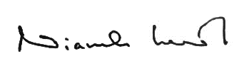
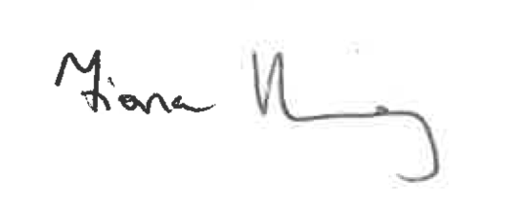
Kind Regards,

_________________________ ____________________________
Fiona Kearney, MSc MBS FACSLM Niamh Leonard, MCRN 15431
Laboratory Manager Clinical Lead for Mortuary Services

